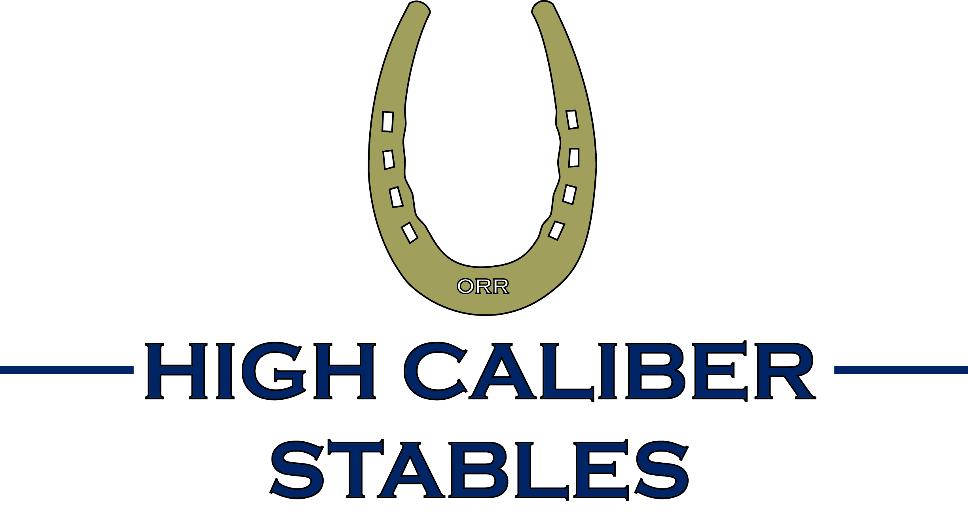
High Caliber Stables
2010 Rider Registration Form

Rider’s Name: Birthdate:
Parents Names:
Address:
City, State, Zip:
Phone: Cell:
Email address:
How did you learn about High Caliber Stables?
Are there any special medical conditions we should know about?
Equestrian Activity Liability Agreement and Risk Acknowledgement

Equestrian and/or Parent agree to hold harmless and release High Caliber Stables (HCS), its managers, members, agents, employees, landlords, officers, directors, representatives, and/or assigns from any and all claims, demands, causes of action, and any other claims whatsoever, whether the same be known or unknown, anticipated or unanticipated, or due to the negligence and/or other act(s) or omission(s) of HCS or the Equestrian. Equestrian and/or Parent further waive any and all rights and claims whatsoever which may otherwise arise from any injury to Equestrian and/or Parent and hereby release HCS and/or any member, manager, agent, landlord, or other representative of HCS from any and all claims, demands, causes of action, and any other claims whatsoever which may result from any economic or non-economic losses due to bodily injury, death, or property damage arising out of the activities of the Equestrian and Parent on or off the real property owned and leased , or used by permission, by HCS and/or its agents, regardless of whether any such activity is authorized, sponsored, or overseen by HCS.

WARNING
Under North Carolina Law, an equine activity sponsor or an equine professional is not liable for any injury to or the death of a participant in equine activities resulting exclusively from the inherent risks of
equine activities.
Chapter 99E of the North Carolina General Statutes

Signed: (Parent or Legal Guardian if minor)
Name of Rider or Parent/Legal Guardian if minor:
Date:

