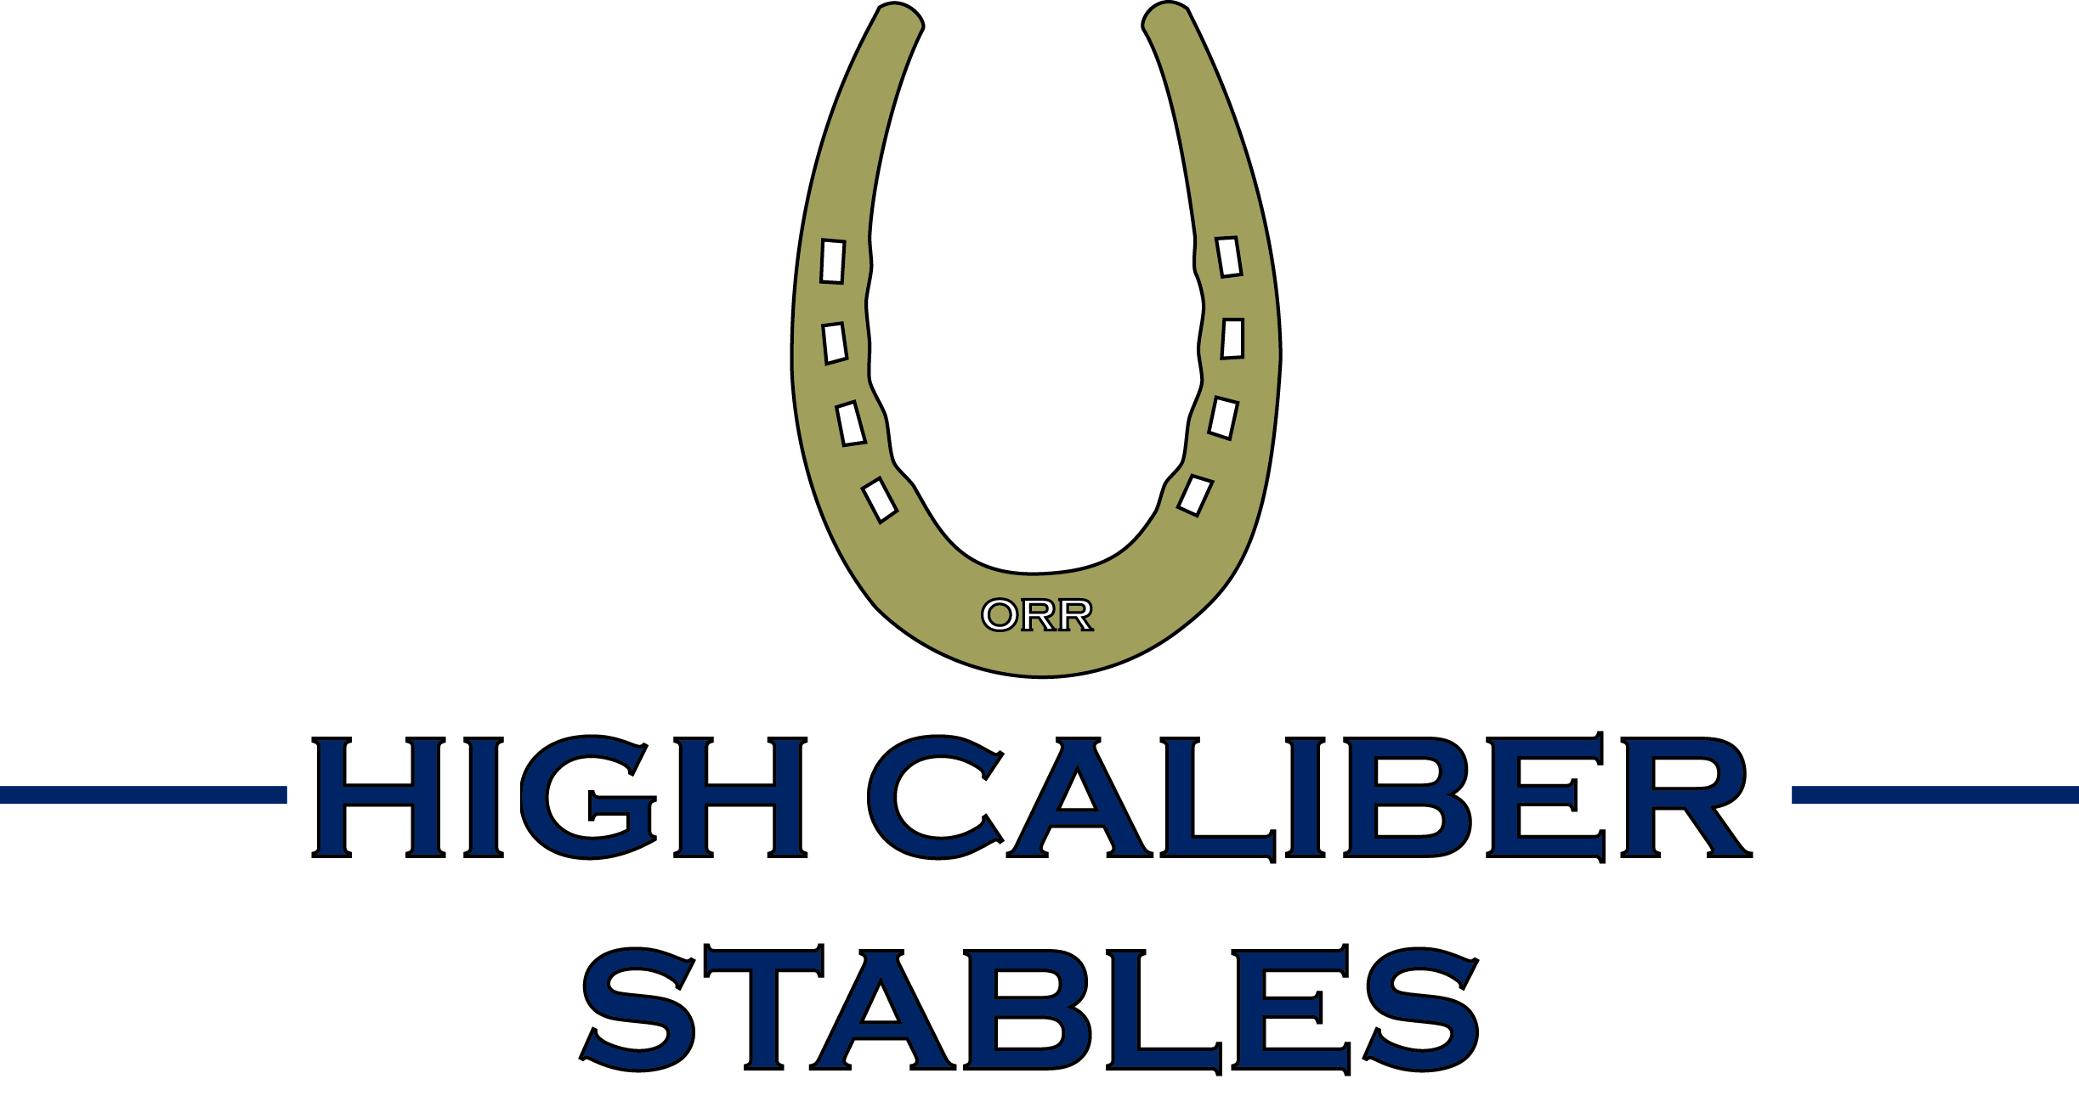

New Rider Information
Who We Are
High Caliber Stables is a premier destination for horseback riding lessons and American Saddlebred Horse Association (ASHA) shows and events. We are a professional horse training facility and horseback riding academy specializing in saddleseat riding. Our instructors, Mary and Evan Orr are both certified through the American Riders Instructors Association and have degrees in Equine Science from William Woods University. Mary Orr also holds a Masters Degree in Education.

Lessons for the Beginner, Intermediate and Advanced Rider
Whether you are a serious rider with a goal to compete in the country’s finest horse shows or a recreational horseback rider looking to have fun and improve your skills, High Caliber Stables has something just for you.

Every student begins with private lessons which are 30 minutes in length. As a rider progresses, they move to small group lessons with approximately 3 to 6 riders. Group lessons are 45 minutes long. Both private and group lessons are $35. Many of our riders ride twice a week in both a private and group lesson.

At the beginning of each month, you will receive an invoice via email for your previous month’s lessons. If you prefer we mail your invoice, please let us know.

Should you need to cancel a lesson, we ask that you do so at least 24 hours in advance. Lessons not cancelled will be subject to a $25 cancellation fee.

What to wear to lessons
Safety is our most important concern and proper attire is always required. We recommend:
- Kentucky jodhpur pants which are long pants with a bell-bottom
- Ankle high boots with a smooth sole
- Riding gloves
- Helmet (such as Aegis)
All of these items can be found at www.ehorseequipment.com and www.showstoppertack.com.

Horse Shows
Many of our riders compete at the top horse shows in the country. However, many do not. At High Caliber Stables, we teach many riders with various skill levels and goals.

Should you be interested in showing, we compete at many shows in the Academy program. We are happy to introduce you to this program as a way for you to become familiar with showing.

If at any time you have any questions, please ask!

